Treating water for reuse
Treating water for reuse

Background
In order to comply with regulations and ensure that the quality of water leaving mine sites is not adversely affecting water users downstream, mining companies develop water management plans to minimize the potential for water contamination, and to prevent the release of polluted water into the environment. Surrounding surface and groundwater quality is monitored, and a number of treatment processes can be used to ensure mine water meets regulatory standards prior to being discharged.
Task
In groups, you are going to carry out three experiments to compare different treatment methods for contaminated water and determine which method produces the best results. Based on your observations you will then design your own filtration method.
Safety
Some things to remember when conducting these experiments:

- Wear gloves and safety glasses when dealing with contaminated (dirty) water
- The powdered flocculant is a chemical so take appropriate safety precautions
- DO NOT drink the water at any stage of these experiments

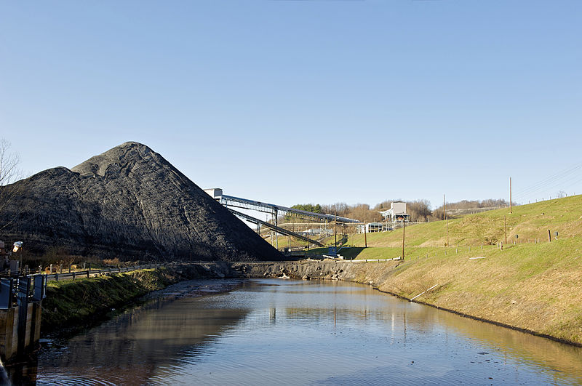

Water storage at a mine (Source:CSIRO)

Experiment 1 – Flocculation/Sedimentation

Aim
The aim of this experiment is to determine the optimum amount alum required to effectively treat dirty water.
Materials
- Dirty water
- 4 x 250ml beakers
- Alum
- Plastic teaspoons
- Stirring rod

Procedure
1. Collect 250mL of dirty water in all four beakers.
2. Keep one beaker as your control
3. Add one teaspoon of alum to beaker one and stir for 30 seconds.
4. Add two teaspoons of alum to beaker two and stir for 30 seconds
5. Add three teaspoons of alum to beaker three and stir for 30 seconds.
6. Record your observations of all beakers in the table below, 1 minute, 2 minutes and 5 minutes
Results
Record your observations of each beaker. (ie. Colour, floating particles)

Time | Control | 1 Teaspoon | 2 Teaspoons | 3 Teaspoons
1 minute
2 minutes
5 minutes

Based on your observations, how many teaspoons of alum do you think is optimum for treating 250mL of water? Explain your reasoning.

Compare the water in the beakers containing the alum with the water in the control beaker. What are your observations? Do you notice any difference in the water that contains the alum?

Experiment 2 - Filtration
Aim
The aim of this experiment is to test the effectiveness of various materials used in water filtration.
Materials
- 4 x 250mL beakers or measuring cylinders
- 3 x funnels
- 3 x filter paper
- Plastic teaspoons
- Sand
- Gravel
- Activated carbon – powdered
- Dirty water
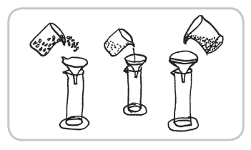
Procedure
- Place a funnel on top of each beaker
- Place filter paper in all of the funnels
- Place sand in the first funnel (about ¾ full)
- Place activated carbon in the second funnel (about ¾ full)
- Place gravel in the third funnel (about ¾ full)
- Pour 250mL of contaminated (dirty) water in to each funnel, collecting the filtered water in the beaker below.

Results
Record your observations about the water collected after the three different filtration methods. (colour, particulates, volume etc)
SAND | GRAVEL | ACTIVATED CARBON

Based on your observations, which of the three filter materials provided the best filtration?

Experiment 3 – Water treatment design
Aim
In this experiment you will design and test your own water filtration method, using the information collected in the previous two experiments.
Materials
- 2 x 250mL beakers or measuring cylinders
- 1 x funnel
- 1 x filter paper
- Stirring rod
- Plastic teaspoons
- Sand
- Gravel
- Activated carbon – powdered
- Alum
- Dirty water

Procedure
1. Determine how many teaspoons of alum you will add to your water.
2. You will need to construct a filter using sand, gravel and activated carbon. In the diagram provided, record the order that you will place these materials in your filter.
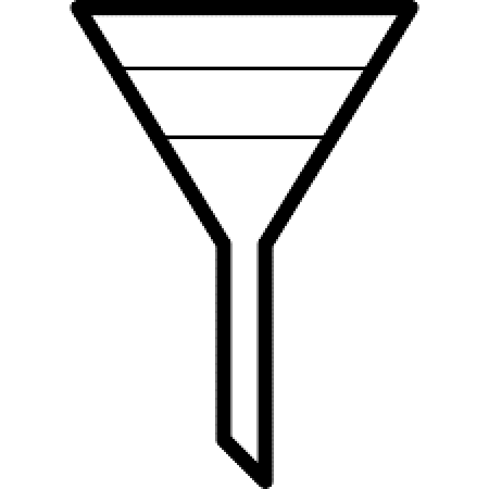

In the space provided below, write a step by step procedure describing the process you will use to treat your dirty water sample.
Discussion

Explain the reasoning behind your water treatment process.

Did you add the alum to the water before or after filtration? Why?

Discuss the design of your multi-stage filter. How/why did you choose the order of the materials in the filter?

Do you think you could make any improvements to your filter?

If you were to conduct this experiment again, would you make any changes to your procedure?

Explain why this filtered water is not suitable for drinking.
If this water was on a mine site, how do you think it could be used?

Do you think this filtered water is suitable for release in to a local creek or water catchment?

