The following diagrams represent the 6 main stages in the generation of electricity from coal.
Coal Fired Power Station Worksheet
They are not in the correct order.
1. Cut out the images and arrange them to create a flowchart that shows how a coal fired power station works.
2. Read through the descriptions and arrange them below each diagram to describe the overall process.
3. Use the completed flowchart to draw an energy chain diagram to show the energy conversions that take place in converting the chemical potential energy in coal into light energy in the light bulb.
When you have finished, glue the flowchart into your book and colour it in.

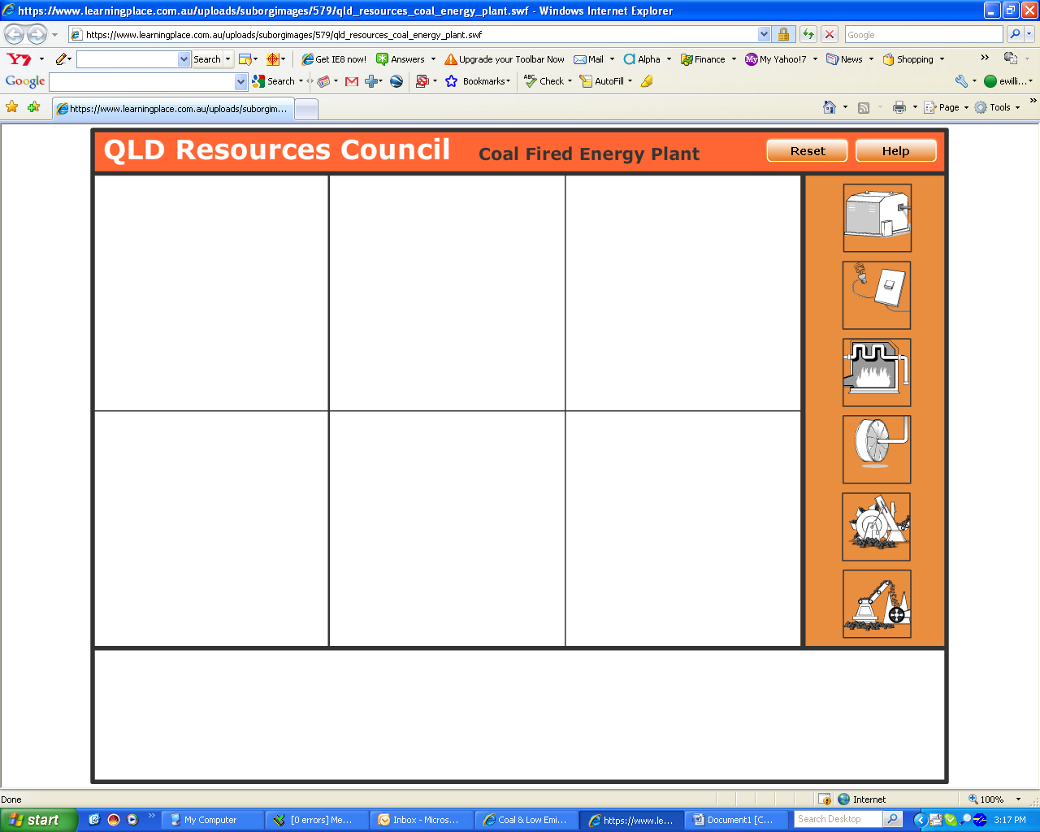Images
Reclaimer
Turbine
Conveyor belt
Electricity
Generator
Boiler

Descriptions
Steam is piped under pressure to the turbine where it spins the turbine at 3000 rpm. The turbine spins the shaft.

The turbine shaft spins a magnetised coil inside a stationary coil of woven wires in the generator to generate electricity.

Electricity is converted to a high voltage so it can travel along power lines into our homes.

Coal is transported along a conveyor belt.

Cold water is pumped into steel pipes where it is heated in the boiler producing steam. The heat for this process is produced by burning coal.

After mining, coal is stockpiled and collected by the reclaimer.

