What is coal gasification?
Coal Gasification
Coal gasification and Integrated Gasification Combined Cycle (IGCC) are low emission coal-fired power generation technologies. The aim of these processes is to generate power with near zero greenhouse gas emissions. It is also an important consideration in the future of hydrogen fuelled electricity generation.

What is Gasification?
Coal gasification is the process of converting coal into a gas by adding steam and oxygen under pressure. The coal is fed into a high-temperature pressurized container along with steam and a limited amount of oxygen to produce a gas.

The gas is known as synthesis gas or syngas and mainly consists of carbon monoxide and hydrogen. The gas is cooled and undesirable components, such as carbon dioxide and sulphur are removed. The gas can be used as a fuel for electricity in gas turbines or the hydrogen can be combusted in turbines to produce power. The gas can also be further processed and concentrated into a chemical or liquid fuel.

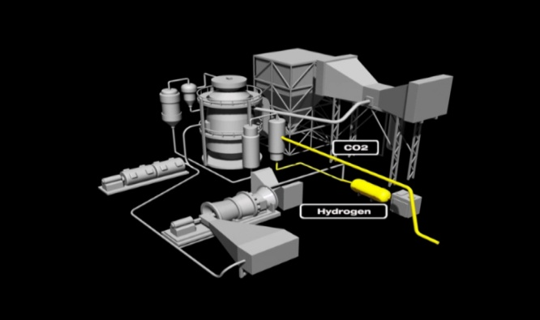
What is Underground Coal Gasification?
Another method to covert coal to a gaseous state is through Underground Coal Gasification (UCG). In UCG energy from coal can be used in the gasification process without removing the coal from underground. In this process a bore hole is drilled down to the coal seam which is then ignited. Oxygen is fed down another bore hole to feed the combustion. The syngas produced by the burning coal is then forced out a separate bore hole to the surface and processed through the IGCC plant.
What is an Integrated Gasification Combined Cycle?
IGCC systems combine a coal gasification unit with a gas fired combined cycle power generation unit. The first stage is the coal gasification process as mentioned above. The second stage takes the cleaned gas and burns it in a conventional gas turbine to produce electrical energy, and the hot exhaust gas is recovered and used to boil water, creating steam for a steam turbine which also produces electrical energy. In typical plants, about 65% of the electrical energy is produced by the gas turbine and 35% by the steam turbine.

Coal gasification (IGCC) Power Plant
Image courtesy of Hydrogen Energy International

What are the advantages of IGCC?
Based on research, demonstration, pilot and early commercial plant results:
- 50% thermal efficiency can be achieved. This is a higher efficiency compared to conventional coal power plants meaning there is less coal consumed to produce the same amount of energy, resulting in lower rates of carbon dioxide (CO2) emissions
- Half the volume of solid wastes is produced as a conventional coal power plant.
- 20-50% less water is used compared to a conventional coal power station.
- A variety of fuels, like heavy oils, petroleum cokes, and coals can be used.
- Up to 100% of the carbon dioxide can be captured from IGCC, making the technology suitable for carbon dioxide storage.
- A minimum of 95% of the sulphur is removed and this exceeds the performance of most advanced coal-fired generating units currently installed.
- Nitrogen oxides (NOx) emissions are below 50 parts per million. This is lower than many of today’s most advanced coal-fired generating units.
- The syngas produced from the gasifier unit can be burned in a gas turbine for electricity generation or used as a fuel in other applications such as hydrogen powered fuel cells.

What are the disadvantages of IGCC?
- Technology has only been tested on a small scale to date. The technology needs to be proven on a large commercial scale to prove large volumes of greenhouse gases can be managed
- High cost of plant and equipment
- Lack of approved standards and methods for projects¹.

For more information also see NewGenCoal, CSIRO Energy, Mark Project, PowerMag, CO2 CRC, Hydrogen Energy International.
¹Queensland Resources Council acknowledges CO2 CRC as the copyright holders of the Zero Emissions City of the Future (ZETS) resource pack used as a source for this information.

Last updated February 2010.

