How much renewable energy is used in Queensland?
Renewable Energy in Queensland
Renewable energy is used from a number of sources in Queensland. Approximately 6% (745 megawatts (MW)) of the 12,500 (MW) of electricity generating capacity comes from renewable sources.¹ The most significant of these is biomass primarily bagasse or sugar cane waste.

What are the sources of renewable energy in Queensland?
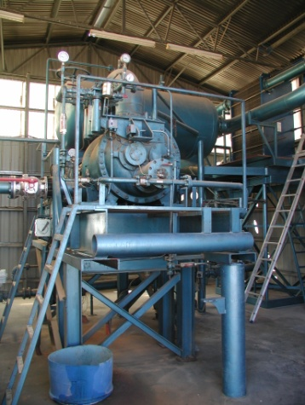
Bagasse
Bagasse (the fibre residue from crushed sugar cane) is used as a fuel in the generation of electricity at many of the sugar mills in northern Queensland, and in a smaller number of mills in south east Queensland. The sugar mills use most of this electricity in the production of sugar, but an increasing proportion of surplus power is sold to the network.
Currently the State has the capacity to generate approximately 415 megawatts (MW) of biomass-fired electricity. The use of biomass as an energy source has added value to Queensland's sugar industry.
Geothermal equipment at Birdsville.
Image courtesy of Ergon Energy.

Biogas
A small amount of biogas (30MW) is generated from a number of waste facilities across Queensland including in Brisbane, Townsville and Swanbank.
Geothermal
Geothermal or hot dry rocks has the potential to produce energy in Queensland.
Currently Australia’s only geothermal power station is located in Birdsville western Queensland². The power station allows geothermal power to meet 25% of the town’s electricity demand (80 kilowatts.) Research is currently being conducted to investigate the amount of energy that could be obtained from these ‘hot rocks’.
Though much of the initial interest in geothermal energy sources has centred on the deep granite deposits in far south west Queensland, interest is now also being shown in geothermal energy sources closer to existing transmission lines.
Koombooloomba Hydro Dam.
Image courtesy of Stanwell Corporation Limited.

Hydro
Hydro energy or energy from water is generated from Barron Gorge, Kareeya, Koombooloomba and Wivenhoe. It is possible to generate around 169MW of energy from these locations.

Solar
A small percentage of solar energy is used in Queensland, primarily for heating water with 4.8% of households in Queensland using solar hot water systems (144 MW). Photovoltaic cells (6 MW) are increasingly being used in remote area power supplies.
Windy Hill wind farm.
Image courtesy of Stanwell Corporation Limited.

Wind
'Wind farms’, utilising wind generators to produce electricity, are located on Thursday Island³ (450 kilowatts; 10 % of the island’s electricity) and at Windy Hill (12 MW) in far north Queensland. Additional sites in Queensland are being investigated for suitability as to their future use for wind farm electricity production.

Links
Energy in Queensland, Ergon Renewable Energy
¹All energy statistics have been sourced from the Queensland Renewable Energy Plan (DEEDI June 2009).
^{2, 3} Owned and operated by Ergon Energy.
Queensland Resources Council acknowledges the Queensland Department of Employment, Economic Development and Innovation, Ergon Energy and Stanwell Corporation Limited as sources for this information.
Last updated October 2011

