What is liquefied natural gas (LNG)?
Liquefied Natural Gas
Liquefied natural gas (LNG) is a fossil fuel that when burned reduces carbon dioxide (CO₂) emissions by 30–60% in comparison with heavier hydrocarbon fuels.

LNG is natural gas that has been liquefied by a process of cooling it to -161 C, and significantly reducing the volume (to 1/600 of original volume) for transportation. This is similar to reducing the volume of a large beach ball of air to that of a ping-pong ball of liquid.
LNG is colourless, odourless, non-toxic and does not linger in the environment. When spilled on water or land, LNG does not mix with water or soil or leave a residue; it disperses rapidly in the air.
Who produces and uses LNG?
Leading exporters of LNG include Qatar, Indonesia, Algeria, Malaysia, Trinidad, Egypt and Australia. Australia has exported LNG since 1989 and is the third largest LNG producer in the Asia-Pacific region and the fifth largest LNG producer in the world, exporting approximately 13+ million tonnes in 2006. Australia is seen by its customers as a reliable and stable LNG supplier.
The Australian LNG industry makes a significant contribution to the Australian economy with exports currently worth more than $3.2 billion a year.
How is gas liquefied and stored?
Feed gas to the liquefaction plant comes from areas where natural gas or coal seam gas has been extracted from the earth.
The carbon dioxide and water found in the natural gas are removed to avoid freezing up and damaging equipment when the gas is cooled and to meet the size of the pipelines.
The liquefaction process cools the feed gas by using refrigerants. The liquefaction plant may consist of several parallel units (commonly known as “trains”). The natural gas is liquefied at atmospheric pressure.
LNG is a cryogenic liquid. The term “cryogenic” means low temperature, generally below -73°C. LNG is a clear liquid, with a density of about 45% that of water.

The LNG is usually stored in double-walled tanks at atmospheric pressure. The storage tank is actually a tank within a tank. The space between the two tank walls is filled with insulation.
The inner tank, in contact with the LNG, is made of 9% nickel steel, suitable for the low temperatures and loading of LNG. The outer tank is generally made of carbon steel or prestressed concrete.
LNG shipping
From the tanks the LNG is pumped onto LNG tankers which are double-hulled ships specially designed and insulated to prevent leakage or rupture in an accident. The LNG is stored in a special containment system within the inner hull where it is kept at atmospheric pressure and -161°C.
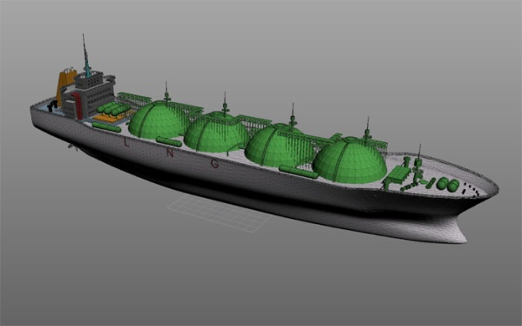
Most of the current LNG ships use spherical (Moss) tanks, and they are easily identifiable as LNG ships because the top half of the spherical tanks are visible above the deck. The typical LNG carrier can transport about 90,000–160,000 cubic metres of LNG, which will provide about 54–96 million cubic metres of natural gas. The typical carrier measures some 275 metres in length, about 43 metres in width and 11 metres in water draft.
LNG tanker
Source: Queensland Resources Council

The ship size is similar to that of a large coal ship but significantly smaller than that of a Very Large Crude oil Carrier. LNG tankers are generally more environmentally ‘friendly’ than other shipping vessels because they burn natural gas in addition to fuel oil as a fuel source for propulsion regasified.

How is LNG regasified?
To return LNG to a gaseous state, it is fed into a regasification plant. On arrival at the receiving terminal in its liquid state, LNG is first pumped to a storage tank, similar to those used in the liquefaction plant, at atmospheric pressure. When it is required for use, it is pumped at high pressure through various components where it is warmed in a manner by passing it through pipes heated by direct-fired heaters, seawater or through pipes that are in heated water.
The vaporized gas is then regulated for pressure and enters a pipeline system as natural gas. Once the LNG is regasified and leaves the regasification terminal, it ceases to be ‘LNG’ and is the same as conventional piped natural gas. Finally, residential and commercial consumers receive natural gas for daily use from local gas suppliers or as gas-powered electricity.

What safety measures are in place to monitor LNG operations?
As a liquid, LNG cannot explode or burn. Security measures for land-based LNG facilities include security patrols, protective enclosures, lighting and monitoring equipment.
Queensland Resources Council acknowledges Gladstone LNG as the source of this information.
Links
For careers in LNG:
GLNG
Santos
Energy Skills Queensland
Last updated February 2010

