What is copper?
Copper
Copper is a metal which is mined from the earth and used for a number of different purposes .

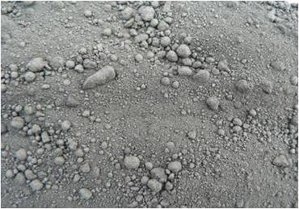
Copper is found in the earth’s crust and often with other metals such as lead, zinc, gold and silver. The metal was formed as a result of volcanic activity which resulted in large masses of molten rock and hot water cooling and then solidifying into copper crystals.
How is copper mined?
Copper can be mined both by open cut and underground mining methods
Crushed copper ore ready for processing
Image courtesy of Xstrata copper

Open-cut Mining
Open cut mining takes place when the ore is close to the surface. An example of open cut mining can be found at the Ernest Henry mine located in the north west of Queensland. In this type of operation the top soil is carefully removed from the surface and stockpiled for later use in rehabilitation. Holes are drilled into the next layer and filled with explosives. After blasting the ore, front end loaders scoop up the broken ore, load it into dump trucks and transport it to the processing plant.
Underground Mining
In underground copper mining the stoping process is used. The ore body is divided into a number of rooms or stopes in which miners drill and blast the ore. A pillar or wall of ore is left in place between each stope to prevent the mine from collapsing. After blasting, the broken material is removed by front end loaders, in many cases remotely controlled, which transport the ore to trains or conveyor belts. From there the ore is crushed in a primary crusher located underground. The crushed ore is removed using skips which hoist the mineralised rock to the surface ready for processing. The stopes can then be backfilled using waste materials.
How is copper processed?
To separate the mineral from the ore, the ore is ground in steel ball and rod mills located on the surface. The ground ore is then further separated in flotation cells which with the addition of air, water and chemicals float the valuable mineral to the surface while the waste drops down to the base of the cell.
The material which is now in a concentrated form is dried and smelted to recover the metal. The ore concentrate is mixed with other materials called fluxes then treated at high temperatures to remove some of the impurities and also change the material chemically.
The molten copper product is cast into shapes called ingots and transported to a refinery for the final purification stage. At the refinery, the copper ingots are placed into vats with stainless steel plates and chemicals. Electricity flows through the chemicals, dissolving the copper which then coats or plates onto the stainless steel plates. Other minerals such as gold and silver fall to the bottom of the tank and are later collected and refined. After seven days the copper, coated plates are removed and the copper sheet which is now 99.9999% copper removed from the plate.
What are the uses of copper?
Copper is a valuable and useful metal because of its properties. It is bright, shiny, a great conductor of heat and electricity, malleable and rust resistant.
Because it is such as good conductor of electricity, copper is used in electrical generators and motors and especially for electrical wiring and cabling. It is found in all electrical appliances such as TVs and hand held mobile devices.
Copper also conducts heat well so it is used in car radiators, air conditioners, home heating systems and even the bases of saucepans.
Due to its malleability it is used in water pipes and can be alloyed with other metals to produce beautiful jewellery and coins such as $1 and $2 while the 5c, 10c, and 50c coins are all 75% copper.
As copper does not corrode easily it is used in plumbing fittings including taps in ship fittings, navigation and surveying equipment.
Copper is the main metal in brass instruments and even can be used as a fungicide, copper sulphate, to stop plant roots from blocking drains and sewerage systems.
Copper in Australia Quick Facts
- The largest copper mining sites are the Mt Isa mine in north western Queensland and the Olympic Dam in central South Australia.
- Australia is rated fourth in the world’s production of copper ore.
- Gold and copper are often mined from the same area e.g. North Parkes in NSW and Ernest Henry in Queensland.
- Just over one third of refined copper produced in Australia is sold to Australian manufacturers.
- China is a major importer of Australian copper.
- In 2009 copper to the value of $5.8 billion was mined in Australia ¹

¹ Australian Bureau Agriculture Resource Economics
Last updated February 2010.
How are the impacts of copper mining managed?
Impact | Steps taken to reduce impacts
The land is changed significantly as a result of open-cut mining. | Top soil is removed and reused later in rehabilitation. Land forms are recontoured to resemble the natural landscape.
Large pits are created from open-cut mining. | Pits can be filled in or used as storage areas for water.
Waste rock is generated from mining. | Waste rock is collected in stockpiles, which are later contoured, covered with topsoil and revegetated. In underground mines waste rock can be used to back fill stopes.
Waste from minerals processing is collected in tailings dams. | Tailings dams can eventually be covered with clay, topsoil and revegetated. Monitoring of the tailings occurs post mining.
Dust is emitted from tailings dams, open-cut mine stockpiles and trucks carrying ore. | Water trucks using recycled water whenever possible are used on mine sites to suppress the dust.
Sulphur dioxide gas is emitted from the copper smelter. | Most of the gas can be collected and used to make sulphuric acid for use in fertiliser.

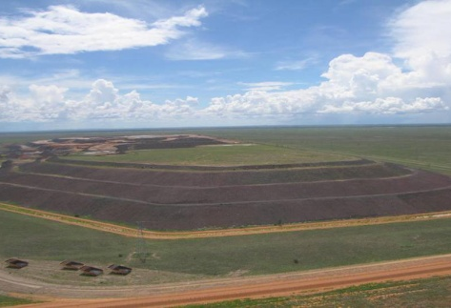
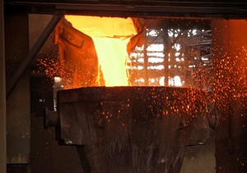

Rehabilitated waste rock stockpile Ernest Henry
Image courtesy of Xstrata copper

Copper Processing
Image courtesy of Xstrata copper

