Oil Shale
Oil Shale
The supply of oil and fuel is critical to transport systems that involve the movement of freight and people by air, rail and road. In Australia, reserves of accessible and inexpensive conventional oil to contribute to this demand are rapidly depleting. Fuel security is declining as the country relies more and more on imported oil products and fuels to power the transport network. Demand for transport fuel, especially heavy transport such as trains and planes, is forecast to continue to grow. In the year 2000 Australia produced enough oil to meet its needs, but by 2008 we produced only about half the oil we require. By 2030, if no new resources are developed, it’s estimated Australia will produce just 18 percent of its oil requirements.
History of Oil Shale
- Shale oil was first produced in Scotland in 1694. Today commercial industries are established in China, Estonia and Brazil.
- In Australia, the first oil shale development started in 1865 at Mount Kembla in New South Wales followed by the opening of other mines in the Great Dividing Range. These mines operated until the 20th century when the imports of cheaper crude oil forced the closure of the industry. A resurgence occurred during World War I and II until the end of World War II when Australia’s only remaining oil shale mine closed. The oil crisis of the 1970s triggered investigation into alternative oil sources with research and development occurring in the United States. Interest in this waned with the decline in oil prices in the 1980s.

- In Australia exploration for oil shale oil deposits continued throughout the 1980s with 10 significant discoveries made in Queensland in the Gladstone and Stuart areas. An oil shale demonstration plant set up in Stuart produced 700,000 barrels of oil between 2001 and 2003.

- From 2005 to 2007, 8 000 tonnes of oil shale from the Queensland deposits were shipped to a pilot plant in Colorado for processing. At present the operations at Stuart are on care and maintenance.

By 2030, Australia’s demand for oil is expected to rise to 470 million barrels per year driven by the need for these transport and aviation fuels. By then, production from conventional oil deposits is predicted to fall to 80 million barrels per year. Australia has only limited domestic supplies of crude oil and relies increasingly on imports to meet demand.
An alternative fuel which could be part of this energy mix is oil derived from oil shale. Geoscience Australia estimates Australia has a total resource of 25 billion barrels of high quality shale oil with 20 billion barrels of this located in Queensland.
What is oil shale?
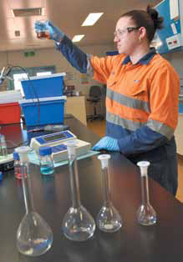
Sometimes known as ‘the rock that burns’, oil shale is an organic-rich sedimentary rock containing kerogen, an organic chemical compound that when heated can produce oil. The rock is younger in geologic age than crude oil-bearing formations and was formed around 50 million years ago from organic matter that was deposited in swamps and lakes. Over millions of years pressure compressed the organic sediments into kerogen-the organic material that sometimes forms before oil in conventional oil formation. In the case of oil shale, the natural forces of pressure and temperature have not yet converted the sediments to crude oil.
Oil Shale Formation
About 40 million years ago, the central Queensland region saw the formation of a series of large, elongated lake basins. At the time, sea levels were 150 meters lower than present. The lake water chemistry varied in response to changing water depth and organic activity, resulting in algal blooms and a variety of other plant and animal life. Sediment and organic matter accumulation would at times exceed the basin floor subsidence and fill the lake causing the water level to shallow and dry out. Over time, the accumulation of the
algae-rich sediments became shale oil.
Shale oil analysis
Image courtesy of QER
How is oil shale mined?
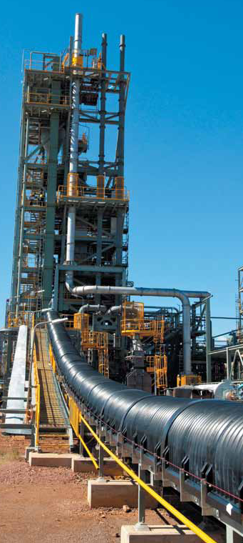
Oil shale mining is usually a cut and fill operation. Prior to extraction, topsoil is removed and stock piled for use in rehabilitation after mining. Large shovels dig up the oil shale and place it onto load haul trucks which then transport the rock to the processing plant to extract the oil.
What happens after mining?
Following processing, the spent shale can either be transported back to the mine to be used as fill or it can be placed in piles. The spent shale is compacted and spread with topsoil, contoured and planted with native vegetation. Alternatively the area can be converted to some other agreed final landform such as a recreational facility.
How is oil extracted?
When oil shale is heated the kerogen is vaporised and cooled or distilled to produce liquid oil. Typical Queensland oil shale contains between 60-220 litres of oil per tonne of rock.
The Paraho II Technology Demonstration Plant
At the Gladstone Plant, the Paraho II Technology has been adopted. Since 2011 the demonstration plant at the New Fuels Development Centre near Gladstone has been producing between 30 and 40 barrels of shale oil a day. Final stages of commissioning for an oil upgrader at the Centre is expected to facilitate the production of small amounts of ultra-low sulphur diesel and aviation fuel in 2013.
What is oil shale used for?
Oil Shale Process Plant
Image courtesy of QER
Shale oil is a suitable feedstock for oil refineries in the production of diesel and aviation fuels. It is considered an alternative transport fuel, readily substitutable for high-grade crude oil.
Queensland Energy Resources (QER) is acknowledged for their significant contribution to this information.


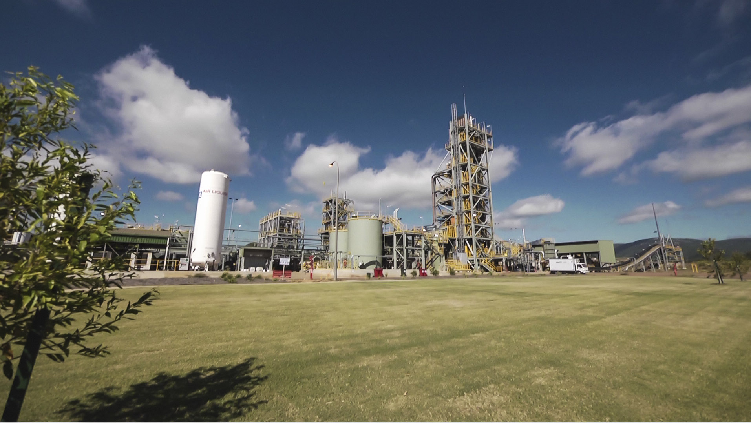
Last updated February 2013.
Clockwise from L-R; Oil Shale Process Plant, Oil Shale used in aviation fuel, Oil Shale used in transport fuel.
Images courtesy of QER

